

POLICY AND STRATEGY ANALYTICS

GROUP REPORT ON ‘PROJECT 27 OF STAR ALLIANCE’

SUBMISSION DATE: April 24th, 2024
SUBMITTED BY: F318593, F314618, F315917, F316511

Files Included:
PPT, Gephi for World data, Gephi for star Alliance

Table of Contents

1.Executive Summary……………………………………………………………………………3

2.Methodology……………………………………………………………………………...…….5
2.1. Data Sources…….………………………………………………………………… 5

2.2. Analytical Techniques………………………………………………………………5

3. Analysis and Airline Evaluation………………………………………………………………7

3.1. Dubai International Airport in Global Context……………………………7
3.2. Dubai International Airport in Star Alliance Context…………………….7
3.3. Suggestion for Emirates as the 27th Member of Star Alliance………….8

4.Conclusion…….…………………………………………………………………………………8

- Executive Summary

Introduction
This report provides a thorough analysis and network analysis for star alliance.., which was established in 1997 with members SAS, Thai, Air Canada, Lufthansa and United. This ground-breaking partnership made it possible to create previously unattainable seamless travel itineraries. In addition to using economies of scale to produce cost savings like shared airline lounges, the alliance also streamlined ticketing procedures through integrated service offerings. This report is designed to assess the network analysis, comparing the worldwide route data relative to Star Alliance's routes, and identify the critical elements—specifically, the geo-demographic traits—that can help in the identification of the perfect 27th airline member.

Methodology
The methodology we employed for the analysis is network analysis and comparative analysis.
We have used Gephi, an advanced open-source network visualization tool, to analyze the hubs and connectivity between the Star Alliance and the larger international airline network. We have conducted two sorts of study: comparative analysis and network analysis.
- Network Analysis: Two datasets were examined, one of which represented the entire airline network and the other of which was unique to Star Alliance. Both network’s nodes (airports) and edges (flight routes) were compared by applying ‘Geo-Layout algorithm’ and ‘average weighted degree’, with an emphasis on centrality measurements like closeness and betweenness as well as metrics like degree, in-degree, and out-degree. By examining the relationship between airports via flight routes, network analysis provides information about the dynamics and effectiveness of international air travel in the context of airport network data. For more detailed analysis please refer to chapter 2.
- Comparative Analysis: We determined areas where the alliance could increase its coverage by contrasting the Star Alliance network with worldwide route data. This strategy assisted in identifying possible new members who may broaden the alliance's operational and geographic scope.

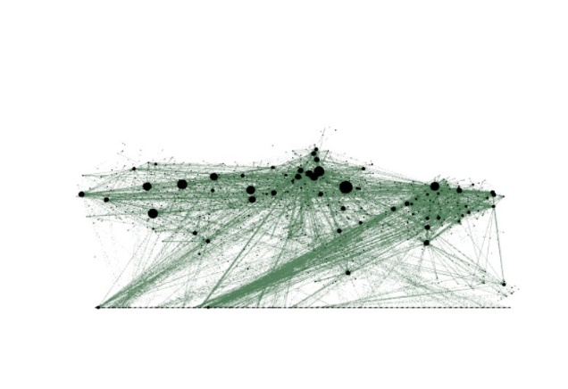
Global Airline route map post Geo Layout Algorithm application
Star Alliance route map post Geo Layout Algorithm application
Figure 1: Comparison between World and star alliance nodes and edges
Findings
The result of our network analysis is present below in this section. Our analysis highlights the comparison between global airline data with the Star Alliance network in order to strategically improve its global connection. After comparison of data we have observed Dubai comes under the top degree places. Emirates, the principal airline at Dubai, is not a member of any major airline alliances, despite its substantial traffic. Adding Emirates to Star Alliance could greatly extend the alliance's network because of Dubai's importance:
- The degree of Dubai International Airport, which is 369, confirms that it is a one of the top global hub, higher than many other top-tier airports. However, its degree of 40 within Star Alliance indicates that there is still demand for network expansion through Emirates.
- Dubai is incredibly accessible around the world, and its close centrality within the Star Alliance network makes it even more so. This suggests that adding Emirates might greatly increase operational efficiency. For more detailed analysis please refer to Chapter 3
- Emirates' inclusion in the alliance presents a strategic opportunity to enhance its global transit connection, as indicated by the difference in betweenness centrality. For more technical analysis please refer to Chapter 3

Joining Star Alliance with Emirates would bridge a huge network gap and offer a number of advantages, including more productive flight paths, improved customer support, and financial gains.

Suggestions
Emirates operates from Dubai, which is among the busiest and most advantageously situated hubs globally. Emirates Inclusion would greatly broaden Star Alliance's network and provide access to new markets, especially in the Middle East, Africa, and Asia, regions where Emirates has powerful operational bases.
By completing a vital network gap, this addition would increase Star Alliance's worldwide reach and provide it a competitive advantage in a economic aspect. Emirates' extensive network, excellent standards of operation, and solid reputation would strengthen the alliance and result in increased route efficiency, increased market share, and better service.

2. Methodology

Data Sources

A thorough analysis of aviation networks serves as the foundation for this search, which aims to find a new member that would be an ideal fit for Star Alliance. Gephi input files, which were manually sorted from reliable datasets, are used in this research. These datasets give insight into two important areas:
- Star Alliance Member Analysis:
Nodes and Edges Files: These files, which are sourced from OpenFlights.org, include information about routes and airports, respectively. We filtered down these datasets to only include airports that are officially mentioned on the Star Alliance website as part of the Star Alliance network for the Star Alliance-specific research. This filtering procedure made sure that our study would be based on the alliance's present operational structure.
- Worldwide Airline Network Analysis:
World Nodes and Edges Files: These files, which is also collected from OpenFlights.org, provide an expanded overview of the airline sector worldwide by including a wider range of airports and the routes that link them. The whole data was utilised to offer a benchmark for comparing and assessing the Star Alliance network.

Analysis Techniques

- Network Analysis:
We looked at network metrics with Gephi to better understand airport connectivity in the context of the Star Alliance and worldwide airline networks. The geographic distribution of these connections has been represented using the Geo Layout Algorithm, and the Average Weighted Degree was also used to calculate each airport's significance based on the weight of its connections. Important metrics consist of:
- Degree: Represents the total number of flights or direct connections that an airport has. This factor helps with the identification of the network's most connected airports.
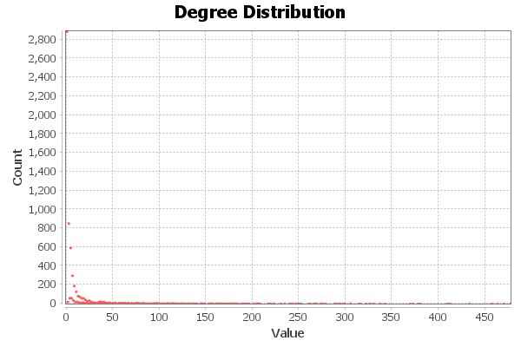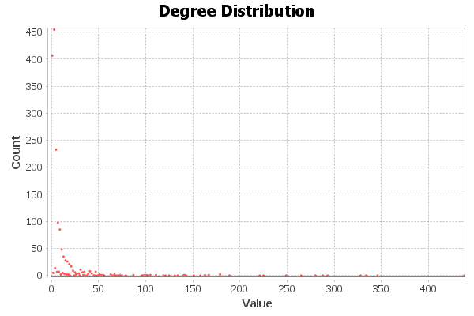
Figure1: Degree distribution for World Figure2: Degree distribution for star alliance

- In-degree/Out-degree: Indicates large traffic flows by measuring the number of arriving and departing airliners.
- Closeness Centrality: Indicates an airport's efficiency and well-planned placement by measuring how fast it can connect to every other airport in the network.

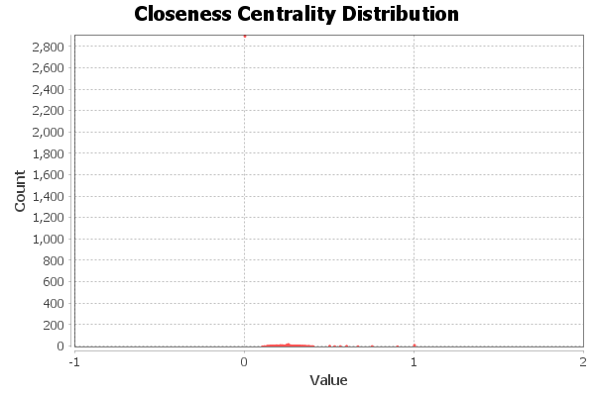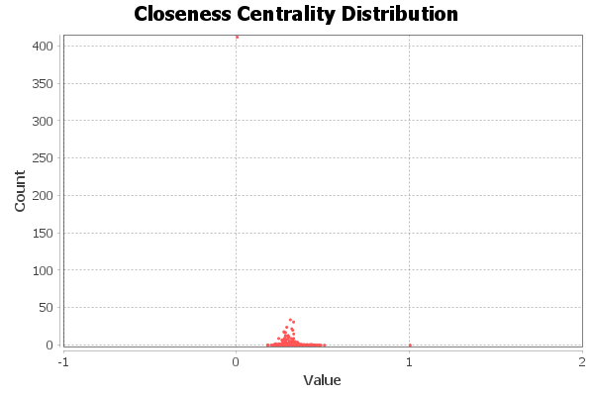
Figure3: Closeness centrality for world Figure4: Closeness centrality for star alliance

- Betweenness Centrality: Airports that are vital for linking various network segments are identified, which highlights their importance to the resilience of the award network.

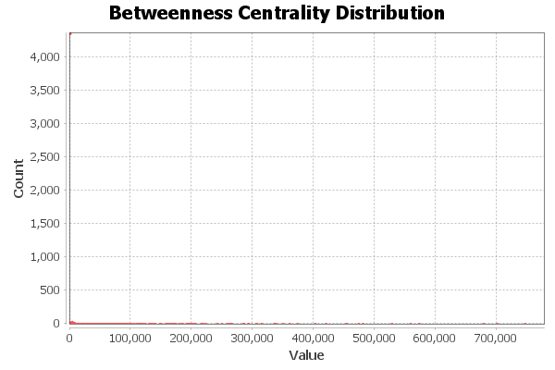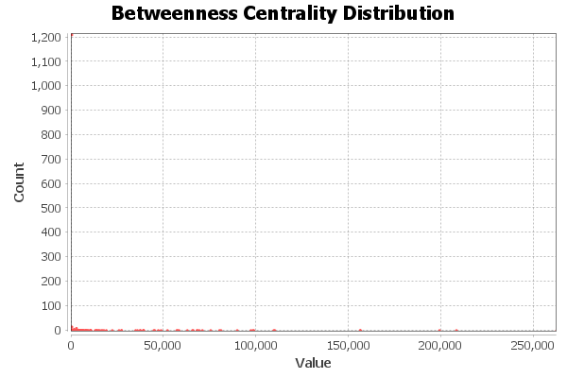
Figure5: Betweenness centrality for world Figure6: Betweenness centrality for star alliance

- Comparative Analysis:
This research finds strategic gaps and potential for growth by comparing the Star Alliance network to data from worldwide airlines:
    - Network Discrepancies: By comparing degree metrics across the two datasets, we identified areas that are not well covered by Star Alliance. This lists possible airports where flight operations might be expanded.
    - Strategic Hubs: By making use of closeness and betweenness centrality, we identify underutilised airports that may be suitable candidates for new, efficient hubs that would enhance alliance-wide connectivity and operational effectiveness.

- Analysis and Airline Evaluation

To determine the strategic expansion potential, we compared worldwide airline data with the Star Alliance network in our analysis. A significant observation is the importance of Dubai International Airport as a worldwide hub, despite its primary airline, Emirates, not being a member of any significant airline alliance. Star Alliance has an exceptional opportunity to improve its worldwide connection by taking into consideration Emirates, which controls one of the busiest hubs in the world.

Analysing the network metrics that have been obtained for Dubai International Airport in context to both the global network and the Star Alliance network:

Dubai International Airport in Global Context:

- Degree (369): Dubai's high degree value places it among the world's most linked airports, indicating its superior hub status. This puts it in the top tier of airports; all of those airports with highest degree values except Dubai are already served by airlines that are either associated with Star Alliance or with competitors.
- Closeness Centrality (0.39527): Dubai's closeness centrality score of 0.39527 indicates that it is easily accessed from other airports within the network, hence solidifying its status as a leading hub and demonstrating its seamless integration into complex route networks.
- Betweenness Centrality (678,183.1409): With exceptionally high betweenness centrality, Dubai is a crucial node in international aviation logistics due to its strategic importance as a transit hub where several shortest paths connecting other airports converge.

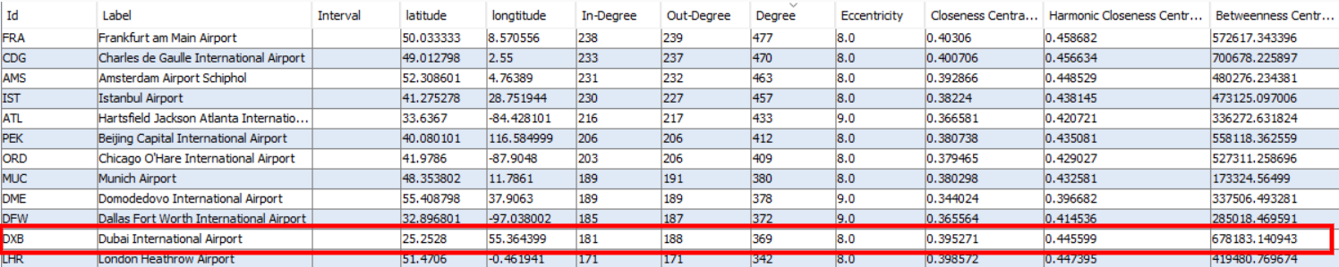
Figure7: Degree, Closeness, Betweenness Centrality of Dubai International Airport in Global Context

Dubai International Airport in Star Alliance Context:

- Degree (40): The Star Alliance network has drastically fewer connections in Dubai due to its lower degree, but with Emirates included, this number could perhaps quickly rise, expanding the network's reach.
- Closeness Centrality (0.402742): Dubai is even more centrally situated when located within the Star Alliance network, as indicated by the somewhat higher closeness centrality within this network.
- Betweenness Centrality (8,565.546508): The Star Alliance network's betweenness centrality decreases drastically, indicating that the alliance's current role as a transit point is smaller than its worldwide role.

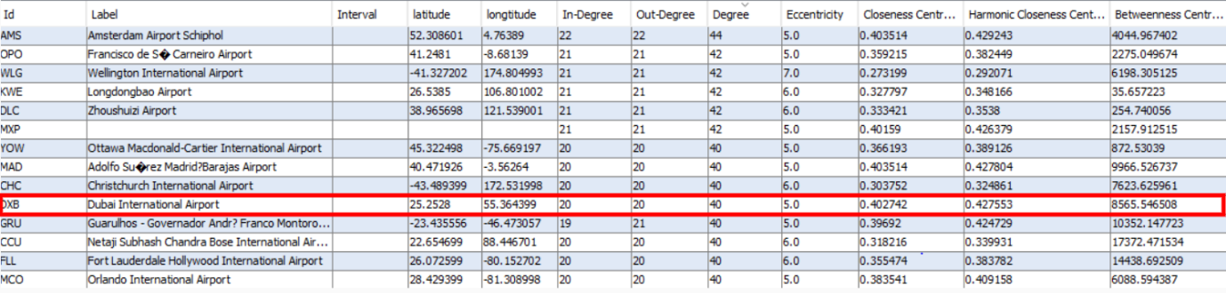
Figure7: Degree, Closeness, Betweenness Centrality of Dubai International Airport in Star Alliance Context

Suggestion for Emirates as the 27th Member of Star Alliance:

- Top Global Hub Status: Considering that the main airlines of other top hubs are already a part of large alliances, Dubai's status as a top global hub is noteworthy. Because of this, Star Alliance should consider Emirates, the main player at Dubai International Airport, to be a significant exception.
- Comprehensive Coverage: Emirates' inclusion would fill a critical gap in Star Alliance's coverage, considering that the top other international hub's dominating airlines are already connected to Star Alliance or one of its competitors. This would not only improve coverage but also keep competitors from acquiring greater authority in an important region.
- Competitive Advantage: Acquiring Emirates as the 27th member would provide Star Alliance a clear advantage over other alliances as it would add a hub that is essential to international travel but has not yet been utilised.
- Operational and Service Excellence: Merging with Emirates would bring in a partner renowned for superior customer service and strong operational standards, which would enhance both the Star Alliance brand and customer satisfaction.
- Economic Benefits: By including Emirates, the Star Alliance network would increase passengers overall. It would also improve route operational efficiency and offer economies of scale.

Incorporating Emirates into Star Alliance would therefore be a strategically sound decision that draws on Dubai's important role in the world's aviation industry.

- Conclusion

In a nut up, the analysis of network data unequivocally places Dubai International Airport as a top global hub, highlighting the strategic advantage of incorporating Emirates into the Star Alliance network. Emirate's inclusion offers a special chance to bridge a significant network gap. By making this change, Star Alliance would expand its reach globally and gain a competitive edge in an essential strategic area that is presently underrepresented in the alliance.
Emirates would make a substantial contribution to the Star Alliance offering with its extensive network, superior operating standards, and well-established brand awareness. This may lead to improved route efficiency, a wider market reach, and higher-quality services overall.
In the fiercely competitive marketplace of international aviation alliances, this strategic alliance promises mutual growth.

