

SKILLS FOR CONSULTING PROJECTS

ASK CONSULTING

GROUP REPORT ON BUSINESS ANALYSIS FOR FW3’S FREEDOM MARKET EXPANSION

SUBMISSION DATE: December 14th, 2023
SUBMITTED BY: F317216, F314618, F315917, F316511
Executive Summary

Introduction
This report provides a thorough analysis and strategic view for FW3 Ltd., a prominent UK producer of household electrical equipment, with a particular emphasis on the company's most recent product launch, "Freedom," an inventive electric mower and hedge clipper combo designed mainly for people 60 years of age and older. Operating in a competitive market with industry heavyweights such as Bosch, Black & Decker, and Makita, FW3 has set itself apart by a deliberate emphasis on product design, customer segmentation, and exceptional support services. The present report aims to analyse preliminary sales data, develop analytics plan to predict market demand, and identify the contributing components, specifically the geo-demographic features, that impact sales patterns for the "Freedom" product.
Methodology
The methodology we employed for the analysis is the main topic of this section. The analytics utilized in our strategy primarily involves predictive analysis, with the goal of predicting future occurrences that are frequently outside of administrative control. These forecasts provide managers the ability to plan and make wise decisions that will lead to better results in the future, especially in terms of performance or sales. The methodology we used for our product study is in line with a comprehensive Business Analytics strategy; nevertheless, it is important to describe the precise procedures and methods used in our analyses.
Business Analysis Methodology (BAM)
Using data to understand what's occurring in a business, predict what could happen next, and make better decisions to help the firm flourish is known as business analytics approach. BAM is closely used in our analyses which is using rich picturing, business canvas model and finding the answers for all the six research questions. BAM has been used for analysing sales with elderly people, area with sales per head and elderly population density with sales per head. Let’s breakdown the steps in simpler structure:
- Problem Situation Structuring: This step involves understanding and defining the business problem or analytics aims to address. For this we have used rich picturing a visual mapping approach, to visualise complex systems, linkages, and interactions. This has been used for initial understanding of overall company FW3 and its product freedom. We have mentioned all the key points and list of issues in our rich picture as shown in Figure 2.1.
- Business Model Mapping: Aligning analytics with critical areas is what it means to use the Business Model Canvas (BMC) in the second stage (BAM) of the Business Analytics Methodology. This alignment guarantees that insights contribute to enhancing the company model, inventing new ways to do things, evaluating the efficacy of various sales strategies, and making prudent use of resources. Business Model Canvas application for FW3 and their product Freedom is basically Customer Segments, key partners, value proposition, customer relationship, key resources, channels, cost structure and revenue streams. Please check Figure 2 for the details mentioned in business model mapping.
- Business Analytics Leverage: Using pilot data and geodemographic data, this analytical section aims to comprehend market behaviors, sales trends, and demographics. To estimate sales in various districts, we have developed regression models based on census data, and exploring multivariate models for getting enhanced accuracy. We have used analytics to obtain practical insights for future company plans and well-informed decision-making.
- Analytics Implementation: During this stage, practical strategies are developed based on the insights obtained from analytics. Strategies which we have concluded is that sales would be in rural landscapes with lower elderly population densities and moreover we have predicted sales for 365 districts in our model 3 and which shows the least error rate. For more detailed analysis please refer to section 2.4 Analytics Implementation.
Findings
The results of the statistical analysis are explained in the following section. In this section, the answers to the six questions are outlined using regression models and distributed charts in accordance with business analytics methodology. To determine the variables influencing sales, we have divided the model into three sections and compare the models to understand the factors affecting sales.
- Identifying the Primary Geodemographic Factor Influencing Sales: The main factor affecting the sales is overall population. To be more specific, we have selected the population between the ages of 60 to 84 which makes up most of the geodemographic factor driving sales inside the area. There is a connection between these factors and overall sales, as seen by the scattered chart below, which is basically our Model1.

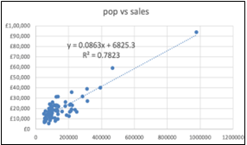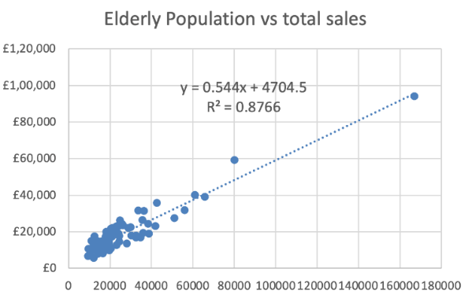
Figure1a: Comparison between population vs sales and elderly population vs sales
As per the below diagram we can see R-squared value for overall population is 0.7823 and R-squared value for elderly population is 0.8766 which shows that sales is happening mostly between elderly people. To get more realistic number for sales we have excluded Birmingham. R-squared value for elderly population after excluding Birmingham is 0.7516. This shows that excluding Birmingham gives us more reliable results as shown in below figure 1b.
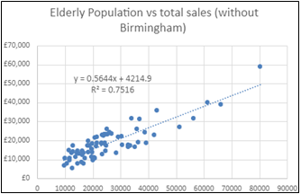
Figure 1b: Elderly population after excluding Birmingham vs sales
- Examining Sales in Rural & Larger Districts: The relationship between area size and sales per person validates our hypothesis that higher sales are typically found in larger districts, particularly those with greater open space, such as rural areas. But rather than being a simple increase, it's more like a curve. We discovered a mathematical pattern that explains how sales per person vary with area size. It's not just a plain old straight line; rather, it traces a specific kind of curved pattern known as a "power model." The R squared value calculated is 0.8519 which is comparably high.
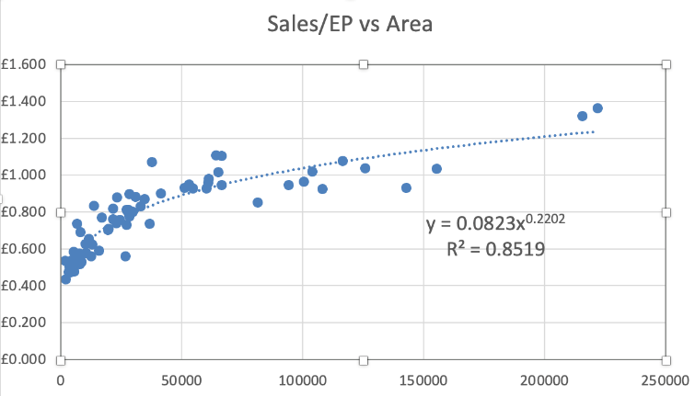
Figure 2: Examining the sales in elderly people vs area.
With the reasoning provided above, we can affirm the hypothesis that higher sales are seen in larger districts—which are more likely to be rural areas with more garden spaces.

- Creating Sales Prediction Multivariate Models: To anticipate sales, this phase involves developing more intricate models that consider a variety of variables at once, such as population size and ruralness. We have used a multivariate model (Model 2) for predicting better sales. With the addition of population and area as predictor variables, Model 2 offers a more comprehensive picture of the elements affecting sales. When area and population are included as forecasting variables, the model produces a higher R-squared value which is 0.889. Therefore, it indicates a better fit and increased capacity to forecast sales within districts.
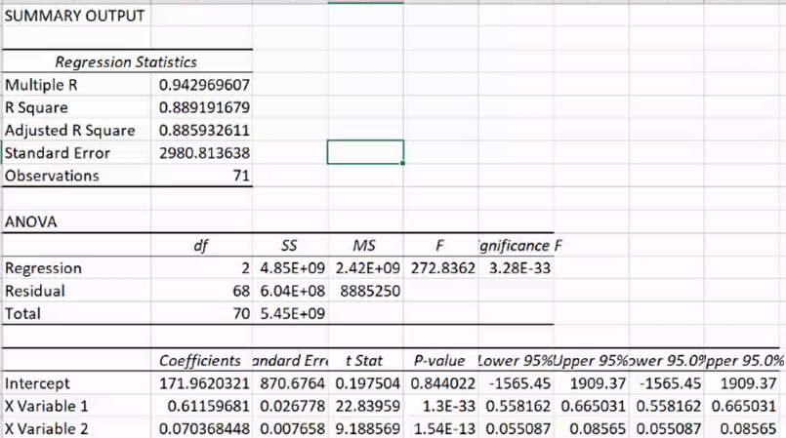
Figure 3: Examining the sales with population and rurality.
Better than Model 1 is the multivariate model (Model 2). By including both population and area as predictor variables, the model improves its fit and predictability of district sales, as demonstrated by a higher R-squared value.
- Examining How Sales Are Affected by Population Density: As we can see another factor affecting sales is elderly population density. For that we have created a scattered graph between elderly population vs sales per head. R-squared value of graph is 0.9415, which is better than both model 1 and model 2 as model 3 focuses entirely on elderly population density. For more detailed analysis please check Research Question 4:
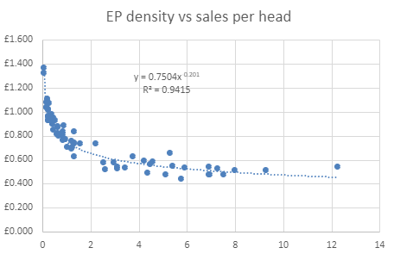
Figure 4: Examining the sales with Elderly population density.
- Forecasting England's Overall Sales as well as Sales by District: According to our business research, total sales prediction for Model 1: 66,82,789 and for model 2 is 66,08,407 which says that Model 2 performs better than Model 1 in some areas, but they seem to have comparable effects on overall sales. But Model 3 having sales prediction as 65,53,801 performed better than both Model 1 and Model 2, demonstrating superiority. For more detailed analysis please refer to Research question 5.

Conclusion
Using three different models (Model 1, Model 2, and Model 3) in our analytical investigation, we carefully evaluated each model's ability to predict our product's sales trends. After a thorough analysis, it was clear that Model 3 had the highest prediction accuracy.
This analysis indicates that more rural landscapes are typically found in areas with lower population densities. It is in these areas that we see a natural tendency towards higher sales of our product freedom. The relationship that exists between lower population density, which is characteristic of rural surroundings, and higher product sales is a crucial finding that suggests that we should strategically concentrate on these areas in our distribution and marketing campaigns.

Further Analytical Survey
In order to improve FW3's decision-making processes, market comprehension, resource optimization, innovation, risk reduction, and ultimately, keeping a competitive edge in the industry, it is highly recommended that more business analytics should be integrated. We can make use of this other department in the same way that we have used business analytics to forecast sales. Application of business analytics is not departmental; it can be found in Supply Chain Management, Personalized Marketing, Product Performance Review, and other departments as well. For more detailed analysis please refer to Research Question 6.

TABLE OF CONTENTS

1.Introduction……………………………………………………………………………………………...7
2.Business analytics methodology……………………………………………………………………...7
2.1.Rich picture……………………………………………………………………………………8
2.2.Business model canvas………………………………………………………………………8
2.3.Business analytics leverage……………………………………………………….10
2.3.1. Research question 1……………………………………………………………10
2.3.2. Research question 2……………………………………………………………10
2.3.3. Research question 3……………………………………………………………11
2.4.Analytics implementation………………………………………………………….11
2.4.1. Research question 4……………………………………………………………11
2.4.2. Research question 5……………………………………………………………12
2.4.3. Research question 6……………………………………………………………12
3.References…………………………………………………………………………………………….13

- Introduction:
We analyzed the dynamics of predicting annual sales for Freedom, a product offered by FW3, over 350 districts in England. Using geodemographic data, we determine three distinctive models: Model 1, which is primarily based on population; Model 2, which incorporates both population and district size as predictors; and Model 3, which introduces the additional variable of elderly population density. Our analysis goes beyond the first 72 districts, providing a thorough assessment of each model's predictive capabilities on a larger scale. As we understand more about these models, we evaluate their ability to predict yearly sales, highlighting total expected sales, error rates, and the overall accuracy of each model. Through this research process, we want to get insight into the most dependable predictors of sales in various districts, ultimately supporting FW3 to enhance its market tactics and understanding its product's geodemographic segmentation.
- Business Analytics Methodology (BAM):
The objective of the BAM strategy is to support a business in accomplishing value from analytics, from early ideas to full analytics. (Hindle 2023, p. 6).

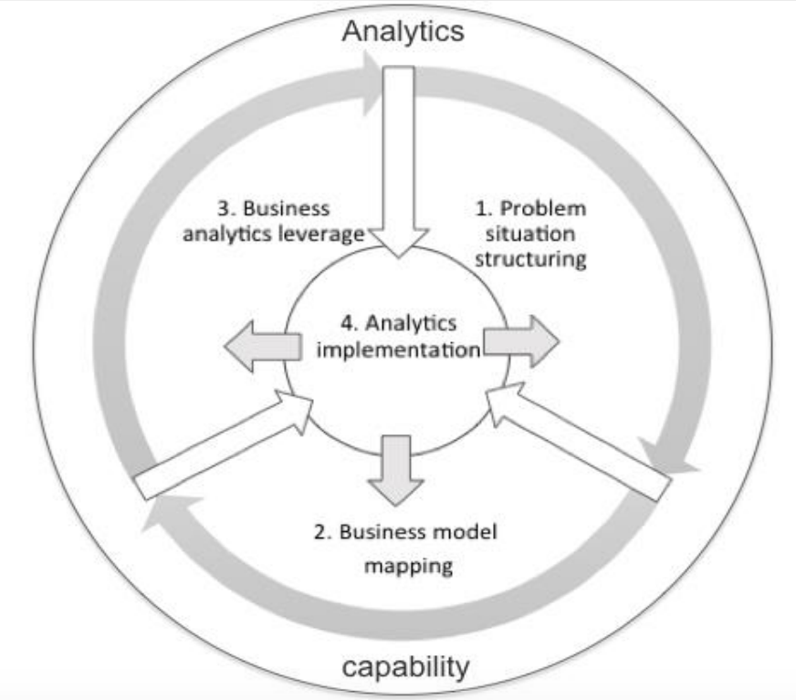
Figure 2: Pictorial representation of Business Analytics Methodology
  - Problem Situation Structuring:
The rich picture created in the first phase of the Business Analytics Methodology (BAM) acts as a visual aid for understanding complicated business challenges. It facilitates the identification of essential components, relationships, and data requirements, hence leading the analytics process. Documentation of insights obtained from the rich picture serves as a basis for the further BAM phases, helping align analytics efforts with business objectives and contribute to effective data-driven solutions.

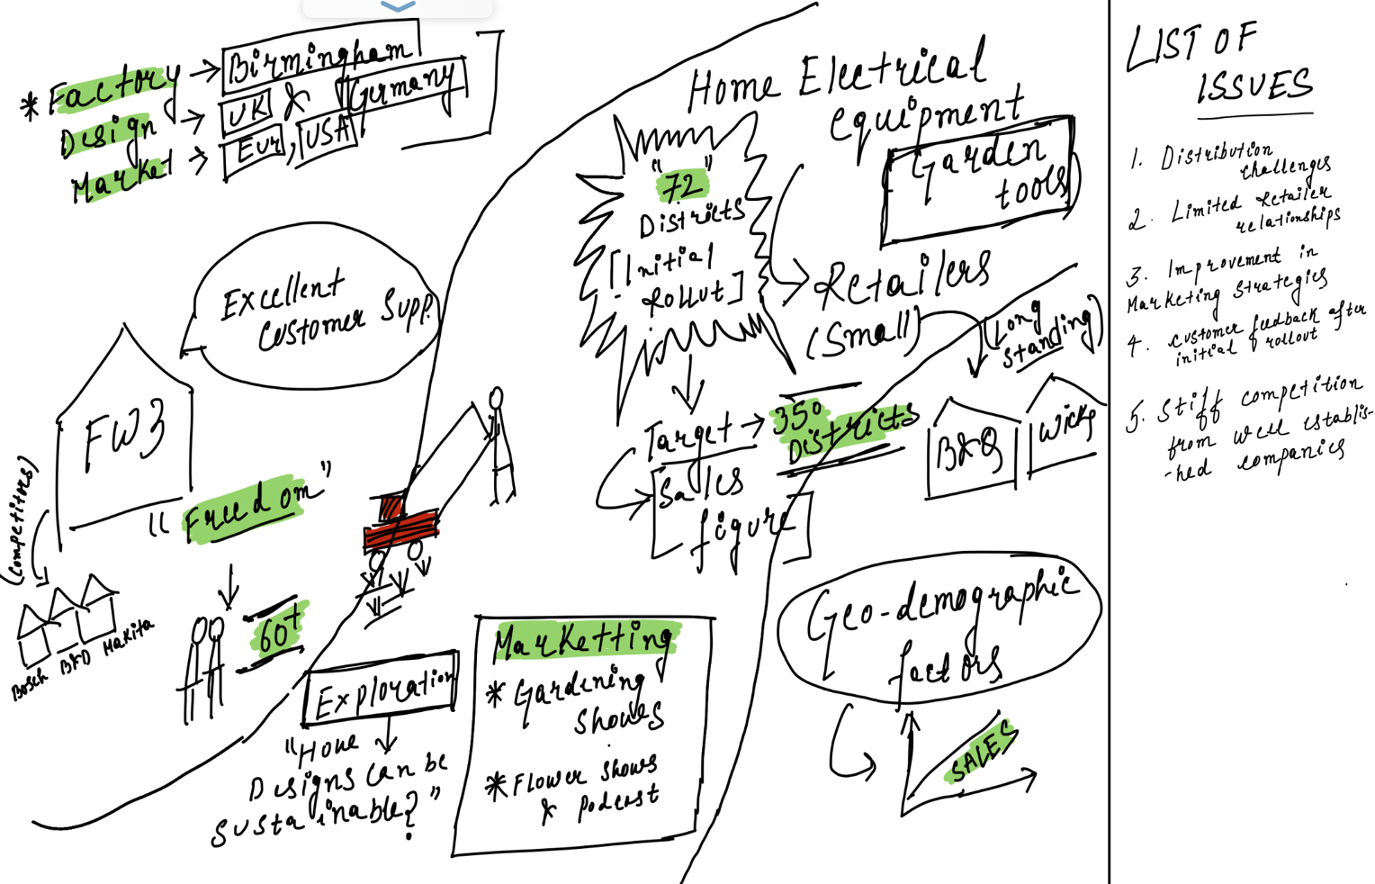
Figure 2.1: Rich picture diagram of FW3 and its product freedom

  - Business Model Mapping:

In the second stage of the Business Analytics Methodology (BAM), implementing the Business Model Canvas (BMC) encompasses strategic alignment of analytics with significant aspects. Aligning analytics toward relevant data ensures that insights contribute to the enhancement of the business model, the identification of optimization opportunities, the evaluation of channel efficacy, and the efficient use of resource allocation. Organizations may iteratively change the canvas by emphasizing customer-centric analytics and revenue diversification operations, resulting in a dynamic framework corresponding to changing business situations.
KEY PARTNERS  Local authorities for pilot programs.  B&Q and Wickes for Retailers. | KEY ACTIVITIES  Designing and developing products.  Manufacturing of a product.  Product marketing and customer support. | VALUE PROPOSITION  Easy to use.  Easy to store.  25% Lighter.  Products are of excellent quality and have an extreme focus on sustainability. |  | CUSTOMER RELATIONSHIPS  Strong relationships with customers  Trust in products and customer support  Supporting gardening shows and events through sponsorship. | CUSTOMER SEGMENT  Aged 60+  Affluent people with gardens.  Consumers who are conscious of the environment.
 | KEY RESOURCES  The manufacturing factory located in Birmingham.  Design teams located in the United Kingdom and Germany.  Partnerships with retailers such as B&Q and Wickes. |  |  | CHANNELS  Marketing through gardening shows on TV.  B&Q and Wickes  Podcasts
COST STRUCTURE  Costs associated with the manufacturing and production processes.  Expenditure related to promoting and publicizing products or services.  Expenses related to the delivery and management of goods. |  |  | REVENUE STREAMS  Sales of electric mowers and hedge clippers (Freedom).  After the purchase services and additional products (accessories).
Figure 2.2: The Business Model Canvas for Freedom

  - Business Analytics Leverage:
Analytical Findings Providing Answers to Research Questions
Research Question 1: The overall population, with emphasis on the older population aged 60 to 84, is the key geodemographic characteristic driving sales within a district. The population and older aged population scatter plot graphs developed against total sales indicate a favorable association between these variables.
Model 1a. Population vs Sales
Based on the equation, for every unit increase in population, the predicted annual sales of Freedom increase by 0.0863 units. The R squared value of 0.7823 indicates that the population variable can explain approximately 78.23% of the variation in sales. This is a high value that indicates a strong association.

Model 1b. Elderly Population (Age 60-84) vs Total Sales
The model shows greater significance when focusing specifically on the older population. The expected annual sales increase by 0.544 units for every unit increase in the older population. The higher R squared value of 0.8766 suggests that the older population variable predicts 87.66% of the variability in sales.

Model 1c. Excluding Birmingham Data:
Excluding data for Birmingham increases the model's reliability as the presence of Birmingham disproportionately affects the results as Birmingham has characteristics that differ significantly from other districts and those characteristics drive a large portion of the sales, excluding it provides a more accurate representation of the general trends in other districts.

The equation represents a linear regression model, with y representing expected annual Freedom sales and x representing the population variable. The coefficient of x (0.5644) suggests that annual sales grow by 0.5644 units on average for every unit increase in population. The R squared score (0.7516) indicates that the population variable can explain 75.16% of the variation in sales.
Research Question 2: The positive relationship between area and sales per head supports the hypothesis that larger districts, which are more likely to be rural with more garden spaces, have greater sales. The non-linear trend implies that the impact of the area on sales per head varies as the district size changes.
- Total Sales per Head was calculated by dividing each district's annual sales by the total number of senior people in each district.
- Generated a model that gave a non-linear trend for Sales per Head vs. Area, precisely a power model.
- The formula represents a power relationship between sales per head and area. Sales per head (y) increase as area (x) increases, but not in a linear fashion. The exponent of 0.2202 reflects the relationship's nonlinearity.
- The R squared value of 0.8519 is relatively high, suggesting that approximately 85.19% of the variability in sales per head can be explained by the area variable in the model.

Research Question 3: The following explanation supports the introduction of a multivariate model (Model 2) for predicting better sales. Here is an overview of the analysis and a comparison to Model 1: According to Model 1, the first variable driving sales is population, and the second variable is rurality, which is captured by the area (district size), as identified in the previous question. Annual sales of each district (y) and total count of elderly people & area as the two variables of x were utilized in the regression function. The equation for the model is y = 0.611×Elderly Population+0.0703×Area+171.962. The R squared value obtained is 0.889. This multivariate model explains approximately 88.9% of the variation in sales.
Comparison with Model1: Model 2 includes population and area as predictor variables, providing an improved overview of the factors influencing sales. The population (0.611) and area (0.0703) coefficients reveal the impact of each variable on sales. The value of the intercept is 171.962. Model 2's R-squared value of 0.889 is greater than Model 1's R-squared value of 0.751.
The multivariate model (Model 2) outperforms Model 1. The model generates a higher R-squared value by including both population and area as predictor variables, indicating a better fit and enhanced ability for predicting sales in districts.

  - Analytics Implementation:

Research Question 4: Model 3 – Elderly Population Density vs. Sales per Head: hypothesis has been made that districts with lower population density are more likely to be rural. Which has been calculated by dividing the total number of elderly people by the area of each district.
A hypothesis has been made that districts with lower population density are more likely to be rural.
Further, Plotted the scattered graph between elderly population density and elderly population sales per head and a non-linear power function model emerged that describes the link between elderly population density and sales per head. The R squared value of 0.9415 shows that the older population density variable can explain approximately 94.15% of the variation in sales per head.
Compared to Other Models (Models 1 and 2): Model 1 has a R squared value of 0.8519 based on the area as a predictor variable. Model 2 has a R squared value of 0.889 and includes both population and area as predictors.
Model 3, which focuses on older population density, exceeds Models 1 and 2 in terms of predicting sales per head, with the greatest R squared value of 0.9415.
These findings substantially support the idea that lower population density is associated with rural areas.

Research question 5: Following the execution of the methods for predicting sales for all 350 districts in England, here is a summary of the results:
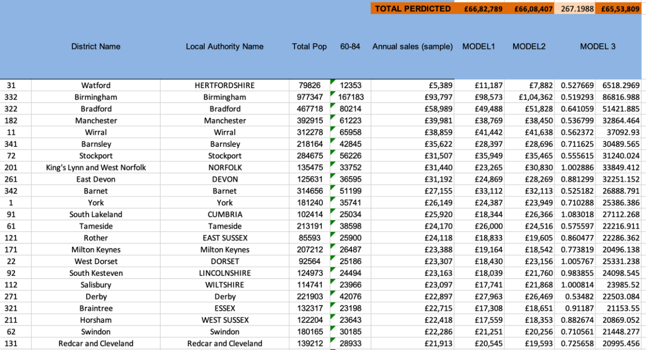
Figure 2.4: Figure representing total sales predicted by all three models.
Total Sales Predictions for All Districts:
- Model 1: 66,82,789
- Model 2: 66,08,407
- Model 3: 65,53,801
Total Sales Comparison: Model 2 beats Model 1, yet total sales are nearly the same. The Model 3 outperforms both the Model 1 and the Model 2, but total sales are comparable.
Error In comparison: Model 1 has greater errors than Model 2. Model 3 has the lowest errors, indicating a higher level of prediction accuracy.
Error Example (District Watford): 5,389 actual sales. Model 1 predicted sales of 11,187 (with a greater margin of error). Predicted Model 2 sales: 7,882. Model 3 Sales Prediction: 6,518 (lowest error).

In conclusion, while total anticipated sales are very comparable among models, the significant differential is in prediction accuracy and errors. Model 3 routinely beats Models 1 and 2, as indicated by lower total anticipated sales and reduced errors, making it a more trustworthy predictor of district annual sales.

Research Question 6: Analytical recommendations that might help the organization in future endeavors:
- Product Performance Analytics: Use analytics to continually monitor and assess Freedom's performance in terms of sales, customer satisfaction, and returns, generating insights for product improvements.
- Analytics may be used to optimize the supply chain, assuring effective inventory management, lowering costs, and reducing product lead times.
- Personalized Marketing Analytics: Utilize data analysis to create personalized marketing campaigns by modifying promotions and collaboration to consumer preferences and behaviors.
References:
Giles Hindle (2023), ‘Topic 3: Analytics Method’, Lecture Slides.

